КЫРГЫЗСКИЙ ТЕХНИЧЕСКИЙ УНИВЕРСИТЕТ им. И. Раззакова

ФАКУЛЬТЕТ ИНФОРМАЦИОННЫХ ТЕХНОЛОГИЙ

Кафедра «ПРОГРАММНОЕ ОБЕСПЕЧЕНИЕ КОМПЬЮТЕРНЫХ

СИСТЕМ»

Дисциплина

Методы оптимизации

Отчет

по практической работе №3

«Golden Section Search Method»

Выполнил: студент группы ПИ-2-16

Абакиров Нурсултан

Проверил:

кандидат технических наук, профессор

Тен Иосиф Григорьевич

# Раздел №1 Наименование работы

Найти решение задачи оптимизации для произвольной заданной нелинейной целевой функции f(x) с заданной допустимой погрешностью Tolerance не более величины 1E–28 методом Золотого Сечения (Golden Section Search Method). Целевая функция f(x) имеет произвольный аналитический вид, составленный из математических функций (полиномов различных степеней, тригонометрических – sin(x), cos(x), exp(x), ln(x), log(x) и. т. д.), которая имеет математический смысл, и для которой существует хотя бы одно решение задачи. Описание Golden Section Search Method – приведено по книге “SCIENTIFIC COMPUTING. An Introductory Survey. Michael T. Heath. University of Illinois at Urbana-Champaign. 1997 by The McGraw-Hill Companies. ISBN 0-07-027684-6”.

# Раздел №2 Спецификация проблемы

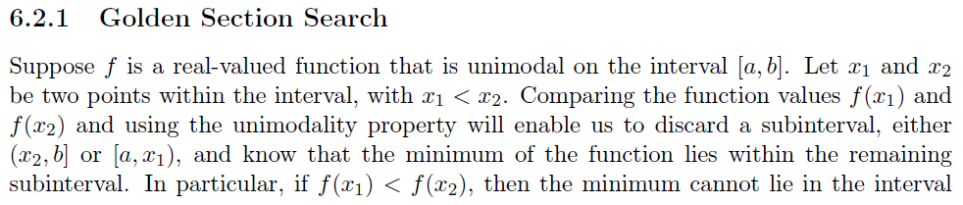 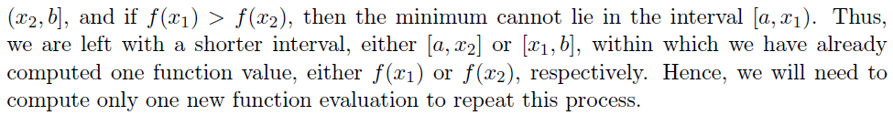 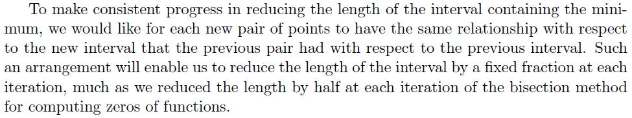 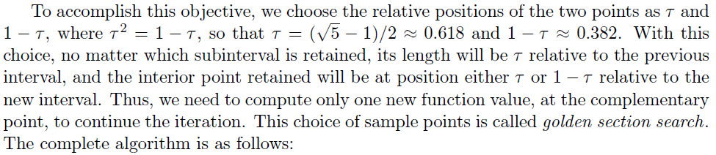

# Раздел №3 Спецификация метода

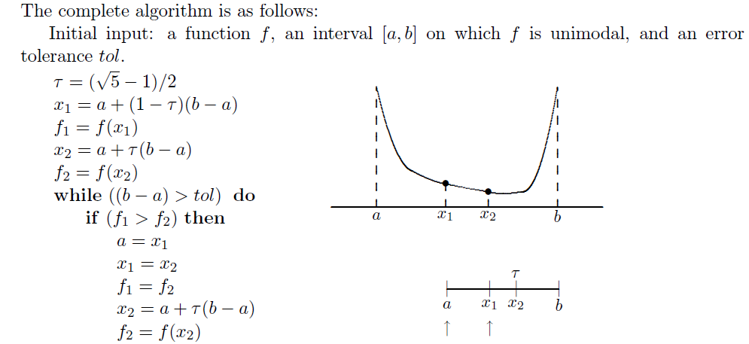 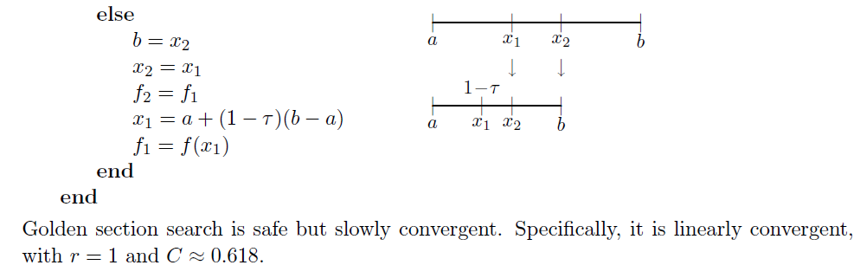

|  |  |
| --- | --- |
| Mathematical Description of Algorithm of the GSSM | Computational Description of Algorithm of the GSSM |
| ***Initial input:*** a function f(x); an interval [a, b] on which f(x) is unimodal; tol;  r:= ;  x1:= a + (1– r)(b–a);  f1:= f(x1);  x2:= a + r(b–a);  f2:= f(x2);  |WHILE ((b–a) > tol DO  | |IF (f1 > f2) THEN /*Find a minimum */  | | a:= x1;  | | x1:= x2;  | | f1:= f2;  | | x2:= a + r(b–a);  | | f2:= f(x2);  | | ELSE  | | b:= x2;  | | x2:= x1;  | | f2:= f1;  | | x1:= a + (1– r)(b–a);  | | f1:= f(x1);  | |ENDIF  |ENDWHILE | ***INPUT*** {[a, b]; tol; Max; f(x)}  ***Body of algorithm***  r:= $(\sqrt{5}-1)/2$; (51/2 – 1)/2;  x1:= a + (1– r)(b–a);  f1:= f(x1);  x2:= a + r(b – a);  f2:= f(x2);  |WHILE K < Max DO  | K:=K+1;  | |WHILE ((b–a) > tol DO  | | |IF (f1 > f2) THEN /*Find a minimum */  | | | a:= x1;  | | | x1:= x2;  | | | f1:= f2;  | | | x2:= a + r(b – a);  | | | f2:= f(x2);  | | |ELSE  | | | b:= x2;  | | | x2:= x1;  | | | f2:= f1;  | | | x1:= a + (1– r)( b –a);  | | | f1:= f(x1);  | | |ENDIF  | |ENDWHILE  |ENDWHILE  ***OUTPUT***  PRINT ‘The optimum solution x* equal’ X2  PRINT ‘The optimum solution was found with the desired tolerance’ tol  PRINT ‘The minimum of objective function f(x*) is’ f2  PRINT ‘The accuracy is ±‘ abs(b–a) |
| [a, b] – an interval on which f(x) is unimodal;  tol – Tolerance;  fk = f(xk) – objective function at point xk. | [a, b] – an interval on which f(x) is unimodal;  tol – Tolerance;  Max – Limit number of iterations. |

# Раздел №4 Стадии проектирования системы

1. Разработка блок-схемы Golden Section Search Method find minimum:



1. Разработка блок-схемы Golden Section Search Method find maximum:



1. Разработка пользовательского интерфейса.

Форма для взаимодействия пользователя с программой представлена ниже:



# Раздел №5 Документирования этапов проектирования интерфейсной формы системы

1. Документирование процесса задания свойств элементов интерфейсной формы системы



|  |  |  |  |
| --- | --- | --- | --- |
| **Number of control** | **Control** | **Property** | **Setting** |
| 1 | Label | Appearance (Text) | Function f(x): |
| Design (Name) | Label1 |
| 2 | Label | Appearance (Text) | a |
| Design (Name) | Label2 |
| 3 | Label | Appearance (Text) | Limit of Time(in mil sec): |
| Design (Name) | Label3 |
| 4 | Label | Appearance (Text) | b |
| Design (Name) | Label4 |
| 5 | Label | Appearance (Text) | Tolerance: |
| Design (Name) | Label5 |
| 6 | Label | Appearance (Text) | Limit of iterations: |
| Design (Name) | Label6 |
| 7 | Label | Appearance (Text) | X1: |
| Design (Name) | Label7 |
| 8 | Label | Appearance (Text) | f(X1): |
| Design (Name) | Label8 |
| 9 | Label | Appearance (Text) | Number Of Iterations: |
| Design (Name) | Label9 |
| 10 | Label | Appearance (Text) | Elapsed time (in mil seconds): |
| Design (Name) | Label10 |
| 11 | Label | Appearance (Text) | Abs(b-a) |
| Design (Name) | Label11 |
| 12 | Label | Appearance (Text) | “” |
| Design (Name) | result |
| 13 | Label | Appearance (Text) | f2(X1): |
| Design (Name) | Label12 |
| 14 | Textbox | Appearance (Text) | x^2-4*sin(x) |
| Design (Name) | fx |
| 15 | Textbox | Appearance (Text) | 1 |
| Design (Name) | a |
| 16 | Textbox | Appearance (Text) | 3 |
| Design (Name) | B |
| 17 | Textbox | Appearance (Text) | 10000 |
| Design (Name) | time |
| 18 | Textbox | Appearance (Text) | 1E-14 |
| Design (Name) | Tolerance |
| 19 | Textbox | Appearance (Text) | 100 |
| Design (Name) | Limit |
| 20 | Textbox | Appearance (Text) | extremum of function |
| Behavior (ReadOnly) | True |
| Design (Name) | x1 |
| 21 | Textbox | Appearance (Text) | F(x1) |
| Behavior (ReadOnly) | True |
| Design (Name) | yf1 |
| 22 | Textbox | Appearance (Text) | F2(x1) |
| Behavior (ReadOnly) | True |
| Design (Name) | yF2 |
| 23 | Textbox | Appearance (Text) | amount of iterations |
| Behavior (ReadOnly) | True |
| Design (Name) | iter |
| 24 | Textbox | Appearance (Text) | elapsed time |
| Behavior (ReadOnly) | True |
| Design (Name) | time |
| 25 | Textbox | Appearance (Text) | b-a |
| Behavior (ReadOnly) | True |
| Design (Name) | b_a |
| 26 | RadioButton | Appearance(Text) | Min |
| Design(Name) | min |
| 27 | RadioButton | Appearance(Text) | Max |
| Design(Name) | max |
| 28 | Button | Appearance(Text) | Run Pocket Search Method |
| Design(Name) | button1 |
| 29 | Button | Appearance(Text) | clear |
| Design(Name) | button2 |
| 30 | Button | Appearance(Text) | excel |
| Design(Name) | button2 |
| 31 | ProgressBar | Design(Name) | progressBar1 |

# 

# Раздел №6 Стадии конструирования ПО

Код программы на SWIFT, ассоциированный с интерфейсной формой и реализует логику Golden Section по поиску корня нелинейного уравнения “ViewController.swift” 

*//*

*// ViewController.swift*

*// esm*

*//*

*// Created by user on 12/8/18.*

*// Copyright © 2018 user. All rights reserved.*

*//*

**import** Cocoa

**class** ViewController: NSViewController {

**@IBOutlet** **weak** **var** functionsInput: NSComboBoxCell!

**@IBOutlet** **weak** **var** aInput: NSTextField!

**@IBOutlet** **weak** **var** bInput: NSTextField!

**@IBOutlet** **weak** **var** toleranceInput: NSTextField!

**@IBOutlet** **weak** **var** kMaxInput: NSTextField!

**@IBOutlet** **weak** **var** tMaxInput: NSTextField!

**@IBOutlet** **weak** **var** minInput: NSButton!

**@IBOutlet** **weak** **var** maxInput: NSButton!

**@IBOutlet** **weak** **var** x1Output: NSTextField!

**@IBOutlet** **weak** **var** yf1Output: NSTextField!

**@IBOutlet** **weak** **var** yf2Output: NSTextField!

**@IBOutlet** **weak** **var** absOutput: NSTextField!

**@IBOutlet** **weak** **var** kOutput: NSTextField!

**@IBOutlet** **weak** **var** elapsedTimeOutput: NSTextField!

**@IBOutlet** **weak** **var** progressBar: NSProgressIndicator!

**@IBOutlet** **weak** **var** messageOutput: NSTextField!

**override** **func** viewDidLoad() {

**super**.viewDidLoad()

*// Do any additional setup after loading the view.*

}

**override** **var** representedObject: **Any**? {

**didSet** {

*// Update the view, if already loaded.*

}

}

**@IBAction** **func** maxClicked(**_** sender: **Any**) {

minInput.state = NSControl.StateValue(rawValue: 0)

}

**@IBAction** **func** minClicked(**_** sender: **Any**) {

maxInput.state = NSControl.StateValue(rawValue: 0)

}

**@IBAction** **func** runBtnClicked(**_** sender: **Any**) {

**self**.clear()

**if** !**self**.isValid() {

**return**

}

**let** f = Parser(expression: functionsInput.stringValue)

**var** a = aInput.doubleValue

**var** b = bInput.doubleValue

**let** tol: Double = toleranceInput.doubleValue

**var** kMax: Int = kMaxInput.integerValue

**let** tMax: Double = tMaxInput.doubleValue

**var** isMin: Bool

**let** r: Double = (pow(5, 1/2) - 1) / 2

**var** x1: Double

**var** x2: Double

**var** f1: Double

**var** f2: Double

x1 = a + (1.0 - r) * (b - a)

f1 = f.run(x: x1)

x2 = a + r * (b - a)

f2 = f.run(x: x2)

**if** minInput.state == NSControl.StateValue(rawValue: 1) {

isMin = **true**

} **else** {

isMin = **false**

}

**let** startTime = Date()

**var** endTime = NSDate()

**let** found: Bool = **false**

**var** isTimeReached = **false**

**var** k: Int = 0

**var** message: String

progressBar.doubleValue = 0.0

**repeat** {

k += 1

progressBar.doubleValue = Double(k * 100 / kMax)

**if** isMin{

message = "Found minimum of function with a given \ntolerance \(tol)"

**if** f1 > f2 {

a = x1

x1 = x2

f1 = f2

x2 = a + r * (b - a)

f2 = f.run(x: x2)

} **else** {

b = x2

x2 = x1

f2 = f1

x1 = a + (1 - r) * (b - a)

f1 = f.run(x: x1)

}

} **else** {

message = "Found maximum of function with a given \ntolerance \(tol)"

**if** f1 <= f2 {

a = x1

x1 = x2

f1 = f2

x2 = a + r * (b - a)

f2 = f.run(x: x2)

} **else** {

b = x2

x2 = x1

f2 = f1

x1 = a + (1 - r) * (b - a)

f1 = f.run(x: x1)

}

}

endTime = NSDate()

**if** k == kMax {

**if** **self**.dialogOKCancel(question: "Continue Search?", text: "Solution was not found in given limit of iterations, add \(kMax) more iterations") {

kMax += kMax

kMaxInput.stringValue = String(kMax)

} **else** {

message = "Not possible to find solution for given \namount of iteration \(kMax)"

}

}

**if** endTime.timeIntervalSince(startTime) >= tMax {

isTimeReached = **true**

message = "Not possible to find solution for given \ntime limit \(tMax)"

}

} **while** abs(b - a) > tol && k < kMax && !isTimeReached && !found

messageOutput.stringValue = message

progressBar.doubleValue = 100

x1Output.doubleValue = x1

yf1Output.doubleValue = f1

yf2Output.doubleValue = f2

absOutput.doubleValue = abs(b - a)

kOutput.stringValue = String(k)

elapsedTimeOutput.doubleValue = endTime.timeIntervalSince(startTime)

}

**@IBAction** **func** clearBntClicked(**_** sender: **Any**) {

**self**.clear()

}

**func** clear() {

x1Output.stringValue = ""

yf1Output.stringValue = ""

yf2Output.stringValue = ""

kOutput.stringValue = ""

absOutput.stringValue = ""

elapsedTimeOutput.stringValue = ""

messageOutput.stringValue = ""

progressBar.doubleValue = 0

*// self.openExcel()*

}

**func** setInvalidInput() {

**self**.alertModal(messageText: "invalid input", informativeText: "")

messageOutput.stringValue = "invalid input"

}

**func** isValid() -> Bool {

**for** raw **in** [functionsInput.stringValue] {

**let** f = Parser(expression: raw)

**do** {

**_** = **try** f.check_run(x: 1)

} **catch** {

**self**.setInvalidInput()

**return** **false**

}

}

**for** el **in** [aInput, bInput, toleranceInput, kMaxInput, tMaxInput, ] {

**if** Double(el!.stringValue) == **nil** {

**self**.setInvalidInput()

**return** **false**

}

}

**return** **true**

}

**func** alertModal(messageText: String, informativeText: String) {

**let** alert = NSAlert()

alert.messageText = messageText

alert.informativeText = informativeText

alert.alertStyle = .warning

alert.addButton(withTitle: NSLocalizedString("OK", comment: "OK"))

alert.runModal()

}

**func** dialogOKCancel(question: String, text: String) -> Bool {

**let** alert = NSAlert()

alert.messageText = question

alert.informativeText = text

alert.alertStyle = .warning

alert.addButton(withTitle: "OK")

alert.addButton(withTitle: "Cancel")

**return** alert.runModal() == .alertFirstButtonReturn

}

*// func openExcel(){*

*// let documentPath: String = Bundle.main.path(forResource: "looking_for", ofType: "xlsx")!*

*// let spreadsheet: BRAOfficeDocumentPackage = BRAOfficeDocumentPackage.open(documentPath)*

*// let worksheet: BRAWorksheet = spreadsheet.workbook.worksheets[0] as! BRAWorksheet*

*// let string: String = worksheet.cell(forCellReference: "A1").stringValue()*

*// print(string) // The Xcode console should now show the word "Alpha"*

*// }*

}

**Подключение библиотечной программы “ Expression ” к программному проекту для выполнения функции парсинга**

Шаг №1: Скачать с сайта https://github.com/nicklockwood/Expression/tree/master/Sources

файл парсера [Expression.swift](https://github.com/nicklockwood/Expression/blob/master/Sources/Expression.swift):

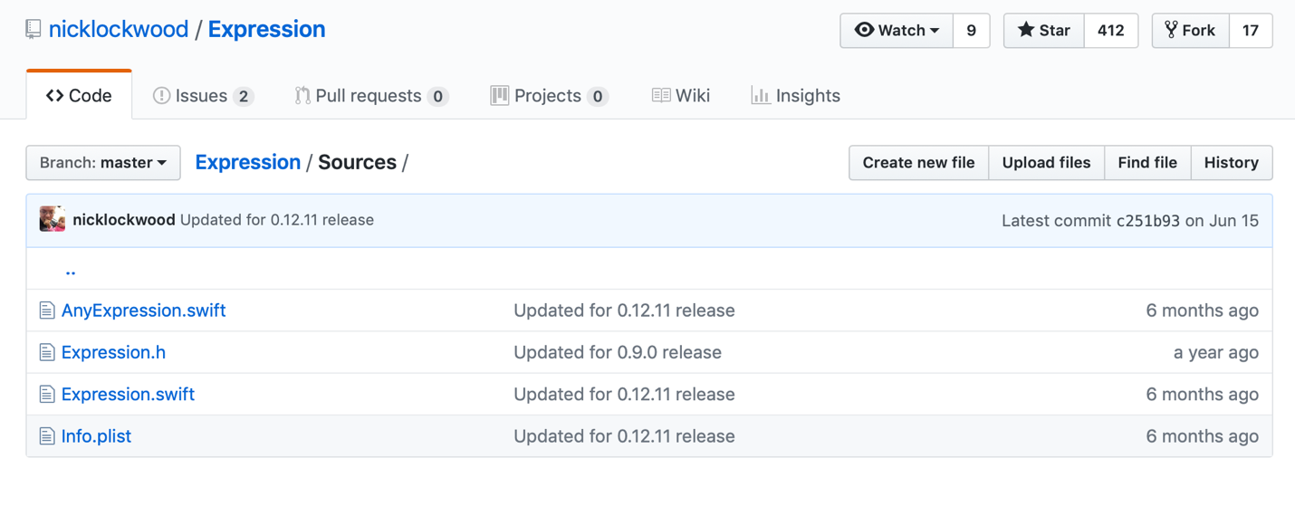

Шаг №2: Вставить скаченный файл в папку проекта:

Шаг №3: Так как парсер не предоставляет полный спектр математических функций, дописываем файл Parser.swift

**import** Foundation

**class** Parser {

**private** **var** expression: Expression

**private** **var** x: Double

**init**(expression: String) {

**self**.x = 0

**self**.expression = Expression("1 + 1")

**self**.expression = Expression(expression, symbols: [

.variable("x"): { **_** **in** **self**.x},

.function("exp", arity: 1): {args **in** exp(args[0])},

.function("log", arity: 1): {args **in** log(args[0])},

])

}

**public** **func** run(x: Double) -> Double {

**self**.x = x

**do** {

**return** **try** **self**.expression.evaluate()

} **catch** {

fatalError()

}

}

}

# Раздел №7 Тестирование

1. Тест №1 функция: x^2-4*sin(x), проверка стандартных функций



1. Тест №2. Проверка на вывод ошибки о недостаточном количестве итераций



1. Тест№3. Проверка на вывод ошибки о недостаточном количестве времени



1. Тест№4. Проверка правильности целевой функции

